***5th week assignment***

**1. create a docker for spring pet clinic**

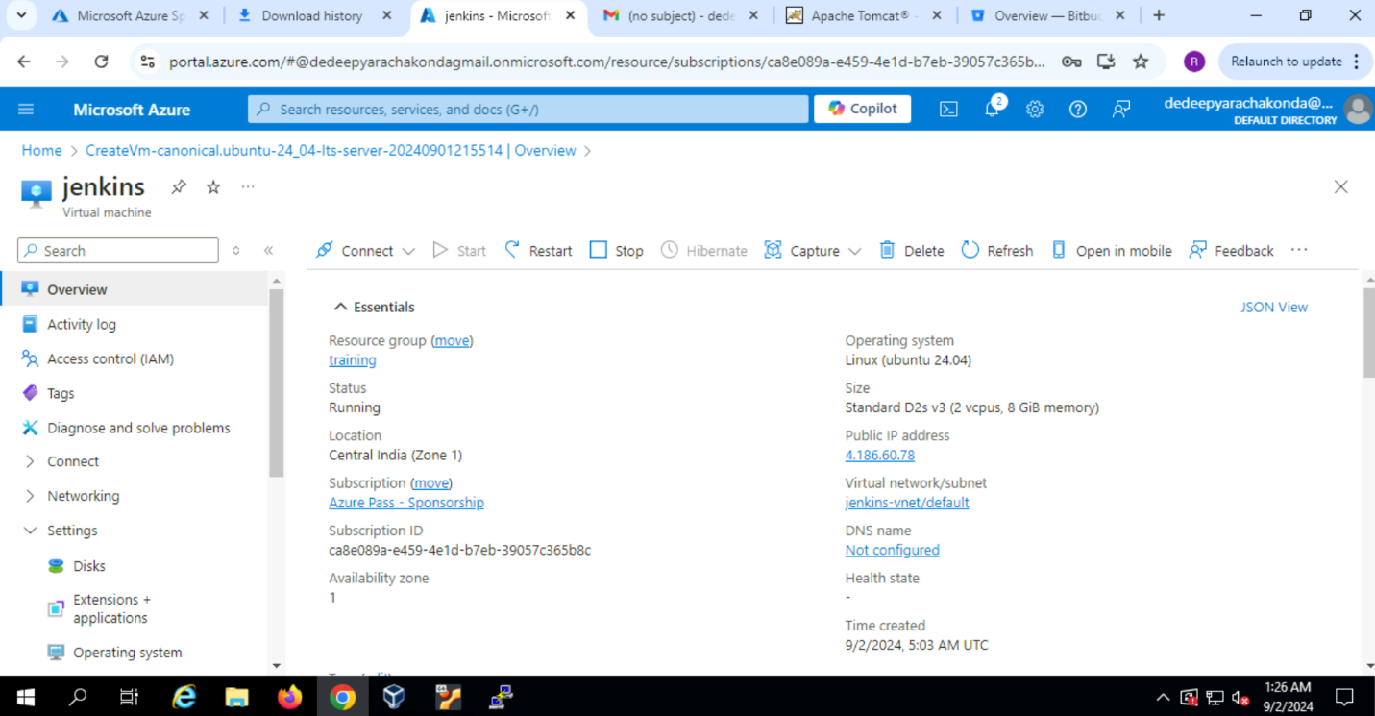

-Frist create a virtual Machine and connect it to putty.

-login to root user

-Clone the GitHub repo

-now create a docker file and put this

**FROM openjdk:17-jdk-slim**

**WORKDIR /app**

**COPY target/spring-petclinic-*.jar app.jar**

**EXPOSE 8080**

**ENTRYPOINT [“java”, “;-jar”, “app.jar”]**

**2. host spring pet clinic in k8s**



